A
Mini Project
On
DEEP LEARNING FOR SMART PHONE-BASED MALARIA PARASITE DETECTION IN THICK BLOOD SMEARS
(Submitted in partial fulfillment of the requirements for the award of Degree)
BACHELOR OF TECHNOLOGY
in

COMPUTER SCIENCE AND ENGINEERING
By
R . Hemasri (217R1A0547)
- Niranjan (227R5A0501)
B.Venkatesh (217R1A0512)

Under the Guidance of
M.Sunitha
(Assistant Professor)



DEPARTMENT OF COMPUTER SCIENCE AND ENGINEERING
CMR TECHNICAL CAMPUS
UGC AUTONOMOUS

(Accredited by NAAC, NBA, Permanently Affiliated to JNTUH, Approved by AICTE, New Delhi) Recognized Under Section 2(f) & 12(B) of the UGCAct.1956,
Kandlakoya (V), Medchal Road, Hyderabad-501401.
2021-25

DEPARTMENT OF COMPUTER SCIENCE AND ENGINEERING

CERTIFICATE

This is to certify that the project entitled “DEEP LEARNING FOR SMART PHONE-BASED MALARIA PARASITE DETECTION IN THICK BLOOD SMEARS” being submitted by R.HEMASRI (217R1A0547), K.NIRANJAN(227R5A0501) & B.VENKATESH (217R1A0512) in partial fulfillment of the requirements for the award of the degree of B.Tech in Computer Science and Engineering to the Jawaharlal Nehru Technological University Hyderabad, is a record of bonafide work carried out by him/her under our guidance and supervision during the year 2024-25.

The results embodied in this thesis have not been submitted to any other University or Institute for the award of any degree or diploma.

M.Sunitha Dr. A. Raji Reddy Assistant Professor DIRECTOR
INTERNAL GUIDE

Dr. Nuthanakanti Bhaskar EXTERNAL EXAMINER
HoD

Submitted for viva voice Examination held on

ACKNOWLEGDEMENT

Apart from the efforts of us, the success of any project depends largely on the encouragement and guidelines of many others. We take this opportunity to express our gratitude to the people who have been instrumental in the successful completion of this project. We take this opportunity to express my profound gratitude and deep regard to my guide
Ms. M. Sunitha, Assistant Professor for his exemplary guidance, monitoring and constant encouragement throughout the project work. The blessing, help and guidance given by him shall carry us a long way in the journey of life on which we are about to embark. We also take this opportunity to express a deep sense of gratitude to Project Review Committee (PRC) Coordinators: Dr.K.Maheswari, Mr. J.Narasimha Rao, Mrs.k.Shilpa, Mr. K. Ranjith Reddy for their cordial support, valuable information and guidance, which helped us in completing this task through various stages.
We are also thankful to Dr.Nuthanakanti Bhaskar, Head, Department of Computer Science and Engineering for providing encouragement and support for completing this project successfully.
We are obliged to Dr. A. Raji Reddy Director for being cooperative throughout the course of this project. We would like to express our sincere gratitude to Sri. Ch. Gopal Reddy, Chairman for providing excellent infrastructure and a nice atmosphere throughout the course of this project.
The guidance and support received from all the members of CMR Technical Campus who contributed to the completion of the project. We are grateful for their constant support and help.
Finally, we would like to take this opportunity to thank our family for their constant encouragement, without which this assignment would not be completed. We sincerely acknowledge and thank all those who gave support directly and indirectly in the completion of this project.

R. Hemasri (217R1A0547)

K. Niranjan (227R5A0501)

B. Venkatesh(217R1A0512)

ABSTRACT

This project is titled as “DEEP LEARNING FOR SMART PHONE-BASED MALARIA PARASITE DETECTION IN THICK BLOOD SMEARS”. This paper presents a novel approach utilizing deep learning techniques to enhance the detection of malaria parasites from smartphone-based imaging of thick blood smears. By leveraging convolutional neural networks (CNNs), the proposed method processes high-resolution images captured by smartphones to identify and classify malaria parasites with high precision. The deep learning model is trained on a diverse dataset of parasite images, enabling it to distinguish between various stages of infection and differentiate between parasitic and non-parasitic features. Experimental results demonstrate that the deep learning-based system significantly outperforms traditional diagnostic methods in terms of accuracy and speed, offering a cost-effective and portable solution for malaria detection. This innovative approach not only improves diagnostic efficiency but also expands access to malaria screening in underserved regions, contributing to better management and control of the disease.

LIST OF FIGURES

FIGURE NO | FIGURE NAME | PAGE NO
Figure 3.1 | Project Architecture | 9
Figure 3.2 | Use case diagram | 10
Figure 3.3 | Class diagram | 11
Figure 3.4 | Sequence diagram | 12
Figure 3.5 | Activity diagram | 13

RESULTS AND DISCUSSIONS

SCREENSHOT NO. | SCREENSHOT NAME | PAGE NO.
Screenshot 5.1 | Predicting parasite from video Result | 23
Screenshot 5.2 | Positive Result | 24
Screenshot 5.3 | Negative Result | 25

LIST OF CONTENTS
ABSTRACT |  |  |  | i
LIST OF FIGURES |  |  |  | ii
LIST OF SCREENSHOTS |  |  |  | iii
1. | INTRODUCTION |  |  | 1
 | 1.1 | PROJECT SCOPE |  | 2
 | 1.2 | PROJECT PURPOSE |  | 2
 | 1.3 | PROJECT FEATURES |  | 2
2. | SYSTEM ANALYSIS |  |  | 3
 | 2.1 | PROBLEM DEFINITION |  | 4
 | 2.2 | EXISTING SYSTEM |  | 4
 |  | 2.2.1 | LIMITATIONS OF THE EXISTING SYSTEM | 5
 | 2.3 | PROPOSED SYSTEM |  | 5
 |  | 2.3.1 | ADVANTAGES OF PROPOSED SYSTEM | 5
 | 2.4 | FEASIBILITY STUDY |  | 6
 |  | 2.4.1 | ECONOMIC FESIBILITY | 6
 |  | 2.4.2 | TECHNICAL FEASIBILITY | 6
 |  | 2.4.3 | BEHAVIORAL FEASIBILITY | 7
 | 2.5 | HARDWARE & SOFTWARE REQUIREMENTS |  | 7
 |  | 2.5.1 | HARDWARE REQUIREMENTS | 7
 |  | 2.5.2 | SOFTWARE REQUIREMENTS | 7
3. | ARCHITECTURE |  |  | 8
 | 3.1 | PROJECT ARCHITECTURE |  | 9
 | 3.2 | DESCRIPTION |  | 9
 | 3.3 | USECASE DIAGRAM |  | 10
 | 3.4 | CLASS DIAGRAM |  | 11
 | 3.5 | SEQUENCE DIAGRAM |  | 12
 | 3.6 | ACTIVITY DIAGRAM |  | 13
4. | IMPLEMENTATION |  |  | 14
 | 4.1 | SAMPLE CODE |  | 15
5. | SCREENSHOTS |  |  | 22
6. | TESTING |  |  | 26

 | 6.1 | INTRODUCTION TO TESTING |  | 27
 | 6.2 | TYPES OF TESTING |  | 27
 |  | 6.2.1 | UNIT TESTING | 27
 |  | 6.2.2 | INTEGRATION TESTING | 27
 |  | 6.2.3 | FUNCTIONAL TESTING | 28
 | 6.3 | TEST CASES |  | 28
 |  | 6.3.1 | UPLOADING IMAGES | 28
 |  | 6.3.2 | CLASSIFICATION | 29
7. | CONCLUSION & FUTURE SCOPE |  |  | 30
 | 7.1 | PROJECT CONCLUSION |  | 31
 | 7.2 | FUTURE SCOPE |  | 31
8. | REFERENCES |  |  | 32
 | 8.1 | REFERENCES |  | 33
 | 8.2 | WEBSITES |  | 34

1.INTRODUCTION

1.INTRODUCTION

PROJECT SCOPE
This project is titled as “DEEP LEARNING FOR SMART PHONE-BASED MALARIA PARASITE DETECTION IN THICK BLOOD SMEARS”. The rapid and accurate detection of malaria parasites in thick blood smears is crucial for effective diagnosis and treatment, especially in resource-limited settings. This paper presents a novel approach utilizing deep learning techniques to enhance the detection of malaria parasites from smartphone-based imaging of thick blood smears. By leveraging conventional neural networks (CNNs), the proposed method processes high-resolution images captured by smartphones to identify and classify malaria parasites with high precision.

PROJECT PURPOSE

This project explores the potential of deep learning to revolutionize malaria diagnosis through smartphone-based imaging. By employing convolutional neural networks (CNNs) to analyze images of thick blood smears captured by smartphones, the proposed system aims to provide a rapid, accurate, and accessible diagnostic tool. The introduction of this approach addresses key challenges in malaria detection, including the need for scalable solutions that can be deployed in remote and underserved regions. The integration of deep learning with mobile technology not only enhances diagnostic accuracy but also facilitates timely treatment, ultimately contributing to more effective malaria control and prevention efforts.

PROJECT FEATURES

The main features of this project is malaria can be detected by using smartphone-based imaging and deep learning.High-resolution smartphone cameras capture images of blood smears, which are analyzed by convolutional neural networks (CNNs) to accurately identify malaria parasites. This portable, user-friendly system is ideal for remote settings, reducing dependence on specialized equipment and technicians. It enhances diagnostic speed and accuracy.The deep learning model is trained on a comprehensive dataset of malaria parasite images to accurately identify and classify various stages of infection.

SYSTEM ANALYSIS

2.SYSTEM ANALYSIS

SYSTEM ANALYSIS
System Analysis is the important phase in the system development process. The System is studied to the minute details and analyzed. The system analyst plays an important role of an interrogator and dwells deep into the working of the present system. In analysis, a detailed study of these operations performed by the system and their relationships within and outside the system is done. A key question considered here is, “what must be done to solve the problem?” The system is viewed as a whole and the inputs to the system are identified. Once analysis is completed the analyst has a firm understanding of what is to be done.

2.1 PROBLEM DEFINITION

A detailed study of the process must be made by various techniques like Image processing, feature recognition etc. The data collected by these sources must be scrutinized to arrive to a conclusion. The conclusion is an understanding of how the system functions. This system is called the existing system. Now the existing system is subjected to close study and problem areas are identified. The designer now functions as a problem solver and tries to sort out the difficulties that the enterprise faces. The solutions are given as proposals. The proposal is then weighed with the existing system analytically and the best one is selected. The proposal is presented to the user for an endorsement by the user. The proposal is reviewed on user request and suitable changes are made. This is loop that ends as soon as the user is satisfied with proposal.

2.2 EXISTING SYSTEM

Existing systems for malaria diagnosis primarily rely on traditional methods such as microscopic examination of thick blood smears, which involve manually staining and analyzing blood samples under a microscope. This process requires skilled technicians to identify and count malaria parasites, often making it time-consuming and prone to human error.

2.2.1 LIMITATIONS OF EXISTING SYSTEM

- Limited Accessibility

- Time-Consuming

- Human Error

- High costs

- Less Accuracy

2.3 PROPOSED SYSTEM
The aim of proposed system is to develop a system of improved facilities. The proposed system can overcome all the limitations of the existing system.The proposed system aims to revolutionize malaria detection by integrating deep learning algorithms with smartphone-based imaging technology. This innovative approach leverages the high-resolution cameras of modern smartphones to capture detailed images of thick blood smears, which are then analyzed using advanced convolutional neural networks (CNNs). The deep learning model is trained on a comprehensive dataset of malaria parasite images to accurately identify and classify various stages of infection.

2.3.1 ADVANTAGES OF THE PROPOSED SYSTEM
The system is very simple in design and to implement. The system requires very low system resources and the system will work in almost all configurations. It has got following features:
- Increased Accessibility.
- Cost-Effectiveness.
- Rapid Results.
- Portability and Ease of Use.
- Scalability.
- Improved Patient Outcomes

2.4 FEASIBILITY STUDY
The feasibility of the project is analyzed in this phase and business proposal is put forth with a very general plan for the project and some cost estimates. During system analysis the feasibility study of the proposed system is to be carried out. This is to ensure that the proposed system is not a burden to the company. Three key considerations involved in the feasibility analysis are
- Economic Feasibility
- Technical Feasibility
- Social Feasibility

2.4.1 ECONOMIC FEASIBILITY
The developing system must be justified by cost and benefit. Criteria to ensure that effort is concentrated on project, which will give best, return at the earliest. One of the factors, which affect the development of a new system, is the cost it would require.
The following are some of the important financial questions asked during preliminary investigation:

      - The costs conduct a full system investigation.
      - The cost of the hardware and software.
      - The benefits in the form of reduced costs or fewer costly errors.
Since the system is developed as part of project work, there is no manual cost to spend for the proposed system. Also all the resources are already available, it give an indication of the system is economically possible for development.

2.4.2 TECHNICAL FEASIBILITY

This study is carried out to check the technical feasibility, that is, the technical requirements of the system. Any system developed must not have a high demand on the available technical resources. The developed system must have a modest requirement, as only minimal or null changes are required for implementing this system.

2.4.3 BEHAVIORAL FEASIBILITY
This includes the following questions:

      - Is there sufficient support for the users?
      - Will the proposed system cause harm?
The project would be beneficial because it satisfies the objectives when developed and installed. All behavioral aspects are considered carefully and conclude that the project is behaviorally feasible.

2.5 HARDWARE & SOFTWARE REQUIREMENTS

2.5.1 HARDWARE REQUIREMENTS:
Hardware interfaces specifies the logical characteristics of each interface between the software product and the hardware components of the system. Thefollowing are some hardware requirements.
- Processor | : | Pentium-IV
- Hard disk | : | 16GB and Above.
- RAM | : | 4GB and Above.
- Monitor | : | 5 inches or above.

2.5.2 SOFTWARE REQUIREMENTS:
Software Requirements specifies the logical characteristics of each interface and software components of the system. The following are some software requirements,

- Operating system : Windows 11
- Languages : Python(3.7)
- Backend : Deep Learning
- IDE : Python 3.7(64-bit)

3.ARCHITECTURE

3.ARCHITECTURE

PROJECT ARCITECTURE

This project architecture shows the procedure followed for breed detectionusing machine learning, starting from input to final prediction.
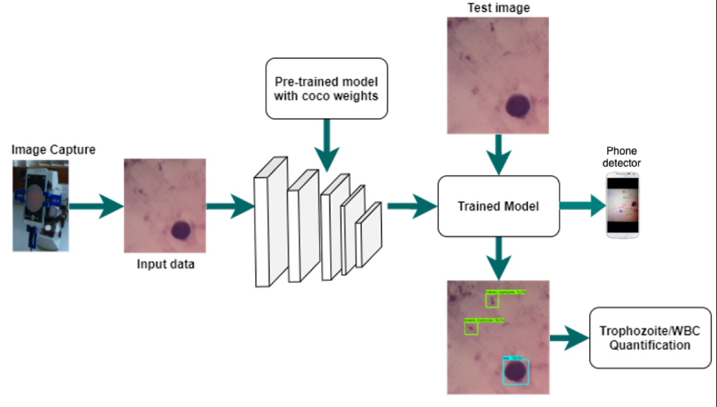

Figure 3.1: Project Architecture of Deep Learning for Smart phone-Based malaria parasite detection in thick blood smears

DESCRIPTION
Input Data: Input data is generally in .jpg format or .png format where the data is fetched and mapped in the data framed from the source columns.

Reading Data: Torch vision library is used to read the data into the data frame.

Separating Features: In this following step we are going to separate the features which we take to train the model by giving the target value i.e. 1/0 for the particular of features.

Normalization: Normalization is a very important step while we are dealing with the large values in the features as the higher bit integers will cost high computational power and time. To achieve the efficiency in computation we are going to normalize the data values.

Training and test data: Training data is passed to the CNN algorithm to train the model. Test data is used to test the trained model whether it is making correct predictions or not.

CNN Algorithm: It analyze images of thick blood smears captured by smartphones,and seperates the parasites.

USE CASE DIAGRAM
In the use case diagram we have basically two actors who are the user and the administrator. The user has the rights to login, access to resources and to view thecrime details. Whereas the administrator has the login, access to resources of the users and also the right to update and remove the crime details, and he can also view the user files.

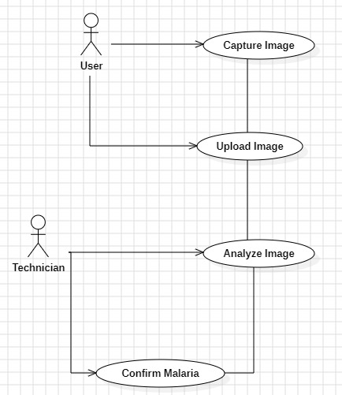

Figure 3.2: Use Case Diagram for Deep Learning for Smart phone-Based malaria parasite detection in thick blood smears

The image depicts a use case diagram for a malaria detection system using image analysis. It involves two actors: the User and the Technician. The diagram shows the flow of actions involved in capturing, uploading, analyzing, and confirming the presence of malaria in an image.The technician might interact with the analyzed result for confirmation, potentially correcting or validating the diagnosis before the user is notified.
This use case diagram outlines a straightforward malaria detection process, illustrating the steps where users and technicians interact with an automated image analysis system.

CLASS DIAGRAM

Class Diagram is a collection of classes and objects.

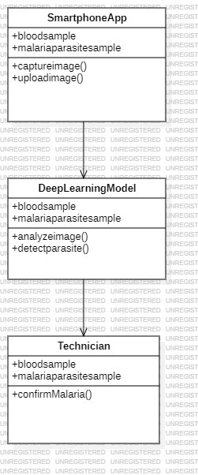

Figure 3.3: Class Diagram for Deep Learning for Smartphone-Based malaria parasite detection in thick blood smears

The image represents a Class Diagram for a malaria detection system involving three key components: SmartphoneApp, DeepLearningModel, and Technician. The diagram illustrates the attributes and methods associated with each class.The DeepLearningModel analyzes the image and passes the results, including any detected parasites, to the Technician.The Technician then confirms the diagnosis based on the results provided by the model.This class diagram shows how each component in the malaria detection system interacts and shares data, highlighting the collaboration between the automated system and the human technician for reliable diagnosis.

SEQUENCE DIAGRAM

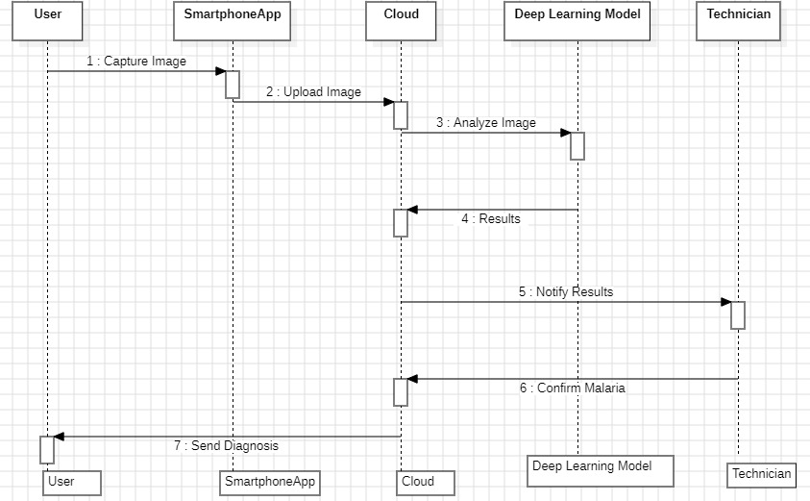

Figure 3.4: Sequence Diagram for Deep Learning for Smart phone-Based malaria parasite detection in thick blood smears

The provided image illustrates a sequence diagram representing the workflow for malaria detection using a smartphone app, cloud services, and a deep learning model. It involves six key components: User, Smartphone App, Cloud, Deep Learning Model, Technician, and Cloud.This sequence diagram depicts the interaction between different components in an automated malaria detection system. It emphasizes the collaboration between cloud computing, AI-powered analysis, and human verification for accurate disease diagnosis.

3.6 ACTIVITY DIAGRAM

Activity diagrams are graphical representations of workflows of stepwise activities and actions with support for choice, iteration and concurrency. In the Unified Modeling Language, activity diagrams can be used to describe the business and operational step-by-step workflows of components in a system. An activity diagram shows the overall flow of control.It describes about flow of activity states.

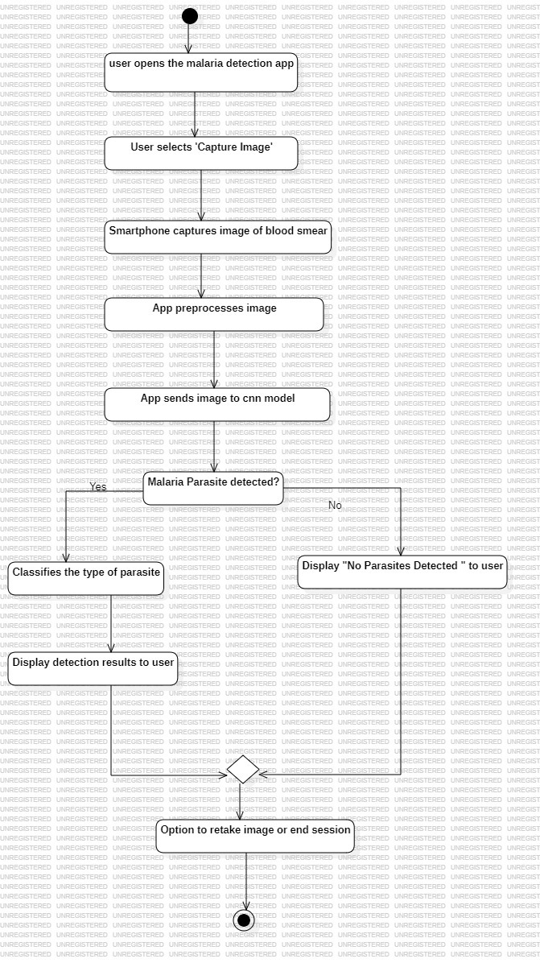

Figure 3.5: Activity Diagram for Deep Learning for Smart phone-Based malaria parasite detection in thick blood smears

4.IMPLEMENTATION

IMPLEMENTATION

4.1 SAMPLE CODE

from tkinter import messagebox
from tkinter import *
from tkinter.filedialog import askopenfilename
from tkinter import simpledialog
import tkinter
import numpy as np
from tkinter import filedialog

from PIL import ImageTk, Image
from keras.optimizers import Adam
from keras.models import model_from_json

from keras.models import Sequential
from keras.layers import Convolution2D
from keras.layers import MaxPooling2D
from keras.layers import Flatten
from keras.layers import Dense
import os
from keras.preprocessing import image
from keras.preprocessing.image import ImageDataGenerator
import cv2
from imutils import paths
import imutils
import matplotlib.pyplot as plt
#{'negative': 0, 'positive': 1}

main = tkinter.Tk()
main.title("Deep Learning for Smartphone-based Malaria Parasite Detection in Thick Blood Smears")
main.geometry("1300x1200")

global filename
global medianFiltered
global cnn_model
global parasites
global wbc

def upload():
global filename
filename = filedialog.askdirectory(initialdir = ".")
pathlabel.config(text=filename)
text.delete('1.0', END)
text.insert(END,'Images path loaded\n')

def removeNoise():
global medianFiltered
index = 0
for root, dirs, files in os.walk(filename):
for fdata in files:
if index == 0:
rawImage = cv2.imread(root+"/"+fdata,0)
rawImage = cv2.resize(rawImage,(800,800))
blur = cv2.GaussianBlur(rawImage,(5,5),0)
retval, thresholded = cv2.threshold(rawImage, 0, 255, cv2.THRESH_BINARY + cv2.THRESH_OTSU)
medianFiltered = cv2.medianBlur(thresholded,5)
contours, hierarchy = cv2.findContours(medianFiltered, cv2.RETR_TREE, cv2.CHAIN_APPROX_SIMPLE)
contour_list = []
for contour in contours:
area = cv2.contourArea(contour)
if area > 100 :
contour_list.append(contour)
cv2.drawContours(medianFiltered, contour_list, -1, (255,0,0), 2)
if len(contour_list) < 15:
cv2.imwrite('data/negative/'+fdata,medianFiltered)
else:
cv2.imwrite('data/positive/'+fdata,medianFiltered)
index = 1
cv2.imshow('Image After Removing Noise',medianFiltered)
cv2.waitKey(0)

def CNN():
global cnn_indices
global cnn_model
cnn_model = Sequential()
cnn_model.add(Convolution2D(32, 3, 3, input_shape = (128, 128, 3), activation = 'relu'))
cnn_model.add(MaxPooling2D(pool_size = (2, 2)))
cnn_model.add(Convolution2D(32, 3, 3, activation = 'relu'))
cnn_model.add(MaxPooling2D(pool_size = (2, 2)))
cnn_model.add(Flatten())
cnn_model.add(Dense(output_dim = 128, activation = 'relu'))
cnn_model.add(Dense(output_dim = 2, activation = 'softmax'))
cnn_model.compile(optimizer = 'adam', loss = 'categorical_crossentropy', metrics = ['accuracy'])
train_datagen = ImageDataGenerator()
test_datagen = ImageDataGenerator()
training_set = train_datagen.flow_from_directory('data/train', target_size = (128, 128),
batch_size = 32,
class_mode = 'categorical',
shuffle=True)
test_set = test_datagen.flow_from_directory('data/train',
target_size = (128, 128),
batch_size = 32,
class_mode = 'categorical',
shuffle=False)
cnn_model.fit_generator(training_set,
samples_per_epoch = 8000,
nb_epoch = 1,
validation_data = test_set,
nb_val_samples = 2000)
if os.path.exists('model/model.json'):
with open('model/model.json', "r") as json_file:
type_model_json = json_file.read()
cnn_model = model_from_json(type_model_json)

cnn_model.load_weights("model/model_weights.h5")
cnn_model._make_predict_function()
cnn_model.summary()
text.delete('1.0', END)
text.insert(END,"CNN Model Generated. See black console to check CNN Layers\n");
else:
cnn_model = Sequential()
cnn_model.add(Convolution2D(32, 3, 3, input_shape = (128, 128, 3), activation = 'relu'))
cnn_model.add(MaxPooling2D(pool_size = (2, 2)))
cnn_model.add(Convolution2D(32, 3, 3, activation = 'relu'))
cnn_model.add(MaxPooling2D(pool_size = (2, 2)))
cnn_model.add(Flatten())
cnn_model.add(Dense(output_dim = 128, activation = 'relu'))
cnn_model.add(Dense(output_dim = 2, activation = 'softmax'))
cnn_model.compile(optimizer = 'adam', loss = 'categorical_crossentropy', metrics = ['accuracy'])
train_datagen = ImageDataGenerator()
test_datagen = ImageDataGenerator()
training_set = train_datagen.flow_from_directory('data/train',
target_size = (128, 128),
batch_size = 32,
class_mode = 'categorical',
shuffle=True)
test_set = test_datagen.flow_from_directory('data/train',
target_size = (128, 128),
batch_size = 32,
class_mode = 'categorical',
shuffle=False)
cnn_model.fit_generator(training_set,
samples_per_epoch = 8000,
nb_epoch = 1,
validation_data = test_set,
nb_val_samples = 2000)
cnn_model.save_weights('model/model_weights.h5')
model_json = cnn_model.to_json()
with open("model/model.json", "w") as json_file:
json_file.write(model_json)
print(training_set.class_indices)
print(cnn_model.summary())
text.delete('1.0', END)
text.insert(END,"CNN Model Generated. See black console to check CNN Layers\n");

def predictParasite():
global parasites
global wbc
parasites = 0
wbc = 0
filename = filedialog.askopenfilename(initialdir="testimage")
rawImage = cv2.imread(filename,0)
rawImage = cv2.resize(rawImage,(800,800))
blur = cv2.GaussianBlur(rawImage,(5,5),0)
retval, thresholded = cv2.threshold(rawImage, 0, 255, cv2.THRESH_BINARY + cv2.THRESH_OTSU)
medianFiltered = cv2.medianBlur(thresholded,5)
contours, hierarchy = cv2.findContours(medianFiltered, ETR_TREE,cv2.CHAIN_APPROX_SIMPLE)
contour_list = []
for contour in contours:
area = cv2.contourArea(contour)
if area > 100 :
contour_list.append(contour)
cv2.drawContours(medianFiltered, contour_list, -1, (255,0,0), 2)
cv2.imwrite('test.png',medianFiltered)
imagetest = image.load_img('test.png', target_size = (128,128))
imagetest = image.img_to_array(imagetest)
imagetest = np.expand_dims(imagetest, axis = 0)
preds = cnn_model.predict(imagetest)
print(str(preds)+" "+str(np.argmax(preds)))
predict = np.argmax(preds)
msg = ""
wbc = len(contour_list)
if predict == 0:
msg = "Test Result Negative"
imagedisplay = cv2.imread('test.png')
orig = imagedisplay.copy()
output = imutils.resize(orig, width=400)
cv2.putText(output, msg, (10, 25), cv2.FONT_HERSHEY_SIMPLEX,0.7, (0, 255, 0), 2)
cv2.imshow("Predicted Result", output)
cv2.waitKey(0)
else:
msg = "Test Result Positive"
contours_poly = [None]*len(contours)
boundRect = [None]*len(contours)
centers = [None]*len(contours)
radius = [None]*len(contours)
for i, c in enumerate(contours):
contours_poly[i] = cv2.approxPolyDP(c, 3, True)
boundRect[i] = cv2.boundingRect(contours_poly[i])
centers[i], radius[i] = cv2.minEnclosingCircle(contours_poly[i])
medianFiltered = cv2.cvtColor(medianFiltered,cv2.COLOR_GRAY2RGB)
for i in range(len(contour_list)):
if len(contour_list[i]) <= 25:
parasites = parasites + 1
cv2.rectangle(medianFiltered, (int(boundRect[i][0]), int(boundRect[i][1])), \
(int(boundRect[i][0]+boundRect[i][2]), int(boundRect[i][1]+boundRect[i][3])), (0,0,255), 2)
cv2.imwrite('test.png',medianFiltered)
imagedisplay = cv2.imread('test.png')
orig = imagedisplay.copy()
output = imutils.resize(orig, width=400)
cv2.putText(output, msg, (10, 25), cv2.FONT_HERSHEY_SIMPLEX,0.7, (0, 255, 0), 2)
cv2.imshow("Predicted Result", output)
cv2.waitKey(0)

def graph():
global parasites
global wbc
wbc = wbc - parasites
height = [wbc, parasites]
bars = ('WBC Count', 'Parasites Count')
y_pos = np.arange(len(bars))
plt.bar(y_pos, height)
plt.xticks(y_pos, bars)
plt.show()

def videoPredictParasite():
global parasites
global wbc
parasites = 0
wbc = 0
videofile = askopenfilename(initialdir = "video")
video = cv2.VideoCapture(videofile)
while(True):
ret, frame = video.read()
print(ret)
if ret == True:
rawImage = frame
rawImage = cv2.cvtColor(rawImage, cv2.COLOR_BGR2GRAY)
rawImage = cv2.resize(rawImage,(800,800))
blur = cv2.GaussianBlur(rawImage,(5,5),0)
retval, thresholded = cv2.threshold(rawImage, 0, 255, cv2.THRESH_BINARY + cv2.THRESH_OTSU)
medianFiltered = cv2.medianBlur(thresholded,5)
contours, hierarchy = cv2.findContours(medianFiltered, cv2.RETR_TREE, cv2.CHAIN_APPROX_SIMPLE)
contour_list = []
for contour in contours:
area = cv2.contourArea(contour)
if area > 100 :
contour_list.append(contour)
cv2.drawContours(medianFiltered, contour_list, -1, (255,0,0), 2)
cv2.imwrite('test.png',medianFiltered)
imagetest = image.load_img('test.png', target_size = (128,128))
imagetest = image.img_to_array(imagetest)
imagetest = np.expand_dims(imagetest, axis = 0)
preds = cnn_model.predict(imagetest)
print(str(preds)+" "+str(np.argmax(preds)))
predict = np.argmax(preds)
msg = ""
wbc = len(contour_list)
if predict == 0:
msg = "Test Result Negative"
imagedisplay = cv2.imread('test.png')
orig = imagedisplay.copy()
output = imutils.resize(orig, width=400)
cv2.putText(output, msg, (10, 25), cv2.FONT_HERSHEY_SIMPLEX,0.7, (0, 255, 0), 2)
cv2.imshow("Predicted Result", output)

else:
msg = "Test Result Positive"
contours_poly = [None]*len(contours)
boundRect = [None]*len(contours)
centers = [None]*len(contours)
radius = [None]*len(contours)
for i, c in enumerate(contours):
contours_poly[i] = cv2.approxPolyDP(c, 3, True)
boundRect[i] = cv2.boundingRect(contours_poly[i])
centers[i], radius[i] = cv2.minEnclosingCircle(contours_poly[i])
medianFiltered = cv2.cvtColor(medianFiltered,cv2.COLOR_GRAY2RGB)
for i in range(len(contour_list)):
if len(contour_list[i]) <= 25:
parasites = parasites + 1
cv2.rectangle(medianFiltered, (int(boundRect[i][0]), int(boundRect[i][1])), \
(int(boundRect[i][0]+boundRect[i][2]), int(boundRect[i][1]+boundRect[i][3])), (0,0,255), 2)
cv2.imwrite('test.png',medianFiltered)
imagedisplay = cv2.imread('test.png')
orig = imagedisplay.copy()
output = imutils.resize(orig, width=400)
cv2.putText(output, msg, (10, 25), cv2.FONT_HERSHEY_SIMPLEX,0.7, (0, 255, 0), 2)
cv2.imshow("Predicted Result", output)
if cv2.waitKey(350) & 0xFF == ord('q'):
break
else:
break
video.release()
cv2.destroyAllWindows()

font = ('times', 16, 'bold')
title = Label(main, text='Deep Learning for Smartphone-based Malaria Parasite Detection in Thick Blood Smears')
title.config(bg='PaleGreen2', fg='Khaki4')
title.config(font=font)
title.config(height=3, width=120)
title.place(x=0,y=5)

font1 = ('times', 14, 'bold')
upload = Button(main, text="Upload Thick Blood Images", command=upload)
upload.place(x=700,y=100)
upload.config(font=font1)

pathlabel = Label(main)
pathlabel.config(bg='DarkOrange1', fg='white')
pathlabel.config(font=font1)
pathlabel.place(x=700,y=150)

noiseButton = Button(main, text="Remove Noise", command=removeNoise)
noiseButton.place(x=700,y=200)
noiseButton.config(font=font1)

cnnButton = Button(main, text="Generate CNN Training Model", command=CNN)
cnnButton.place(x=700,y=250)
cnnButton.config(font=font1)

predictButton = Button(main, text="Upload Test Image & Predict Parasite", command=predictParasite)
predictButton.place(x=700,y=300)
predictButton.config(font=font1)

graphButton = Button(main, text="Extension Predict Parasite From Video", command=videoPredictParasite)
graphButton.place(x=700,y=350)
graphButton.config(font=font1)

exitButton = Button(main, text="Parasite & WBC Count Graph", command=graph)
exitButton.place(x=700,y=400)
exitButton.config(font=font1)

font1 = ('times', 12, 'bold')
text=Text(main,height=30,width=80)
scroll=Scrollbar(text)
text.configure(yscrollcommand=scroll.set)
text.place(x=10,y=100)
text.config(font=font1)

main.config(bg='PeachPuff2')
main.mainloop()

5. SCREENSHOTS

5. SCREENSHOTS

PREDICTING PARASITE FROM VIDEO

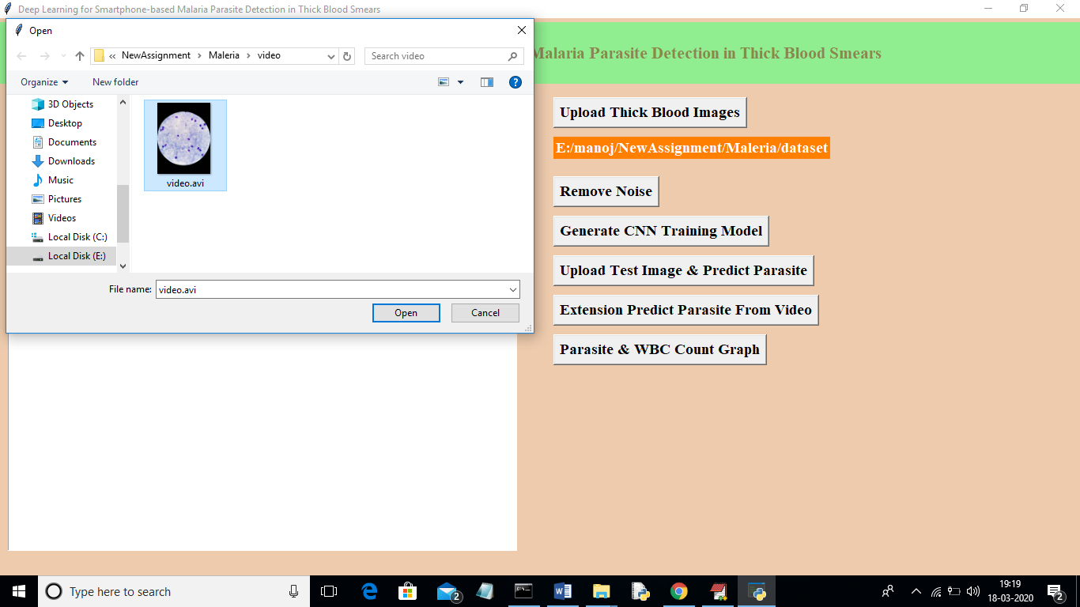

Screenshot 5.1: A Result of Deep Learning for Smart phone-Based malaria parasite detection in thick blood smears

In this project as extension we have added video processing technique from which application can detect malaria parasites from video based test samples. In propose paper author has given concept to detect parasites from images but in extension we can detect in video and images also
Screen shots

POSITIVE RESULT

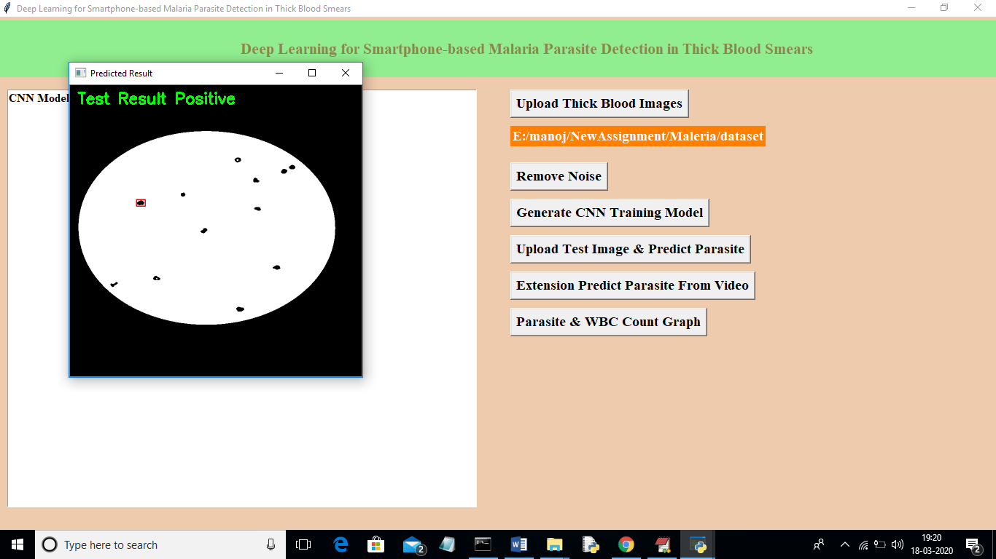

Screenshot 5.2: A result of Deep Learning for Smart phone-Based malaria parasite detection in thick blood smears

5.3 NEGATIVE RESULT

In this screenshot we can see the result of NEGATIVE

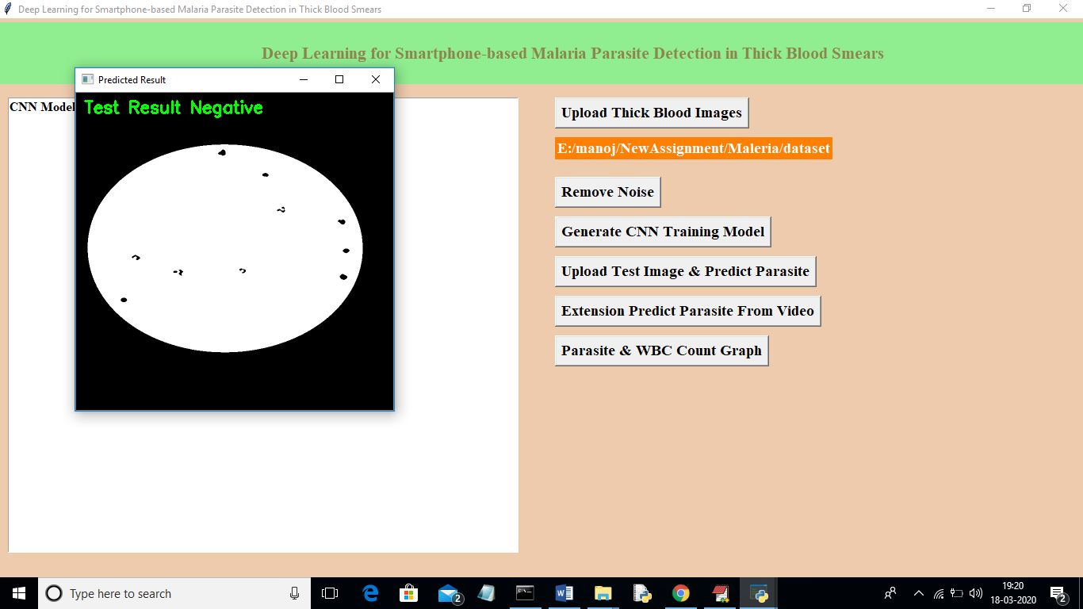

Screenshot 5.3: Result

6.TESTING

6. TESTING

INTRODUCTION TO TESTING

The purpose of testing is to discover errors. Testing is the process of trying to discoverevery conceivable fault or weakness in a work product. It provides a way to check the functionality of components, subassemblies, assemblies and/or a finished product. It is the process of exercising software with the intent of ensuring that the Software system meets its requirements and user expectations and does not fail in an unacceptable manner. There are various types of test. Each test type addresses a specific testing requirement.

TYPES OF TESTING

    - UNIT TESTING

Unit testing involves the design of test cases that validate that the internal program logic is functioning properly, and that program inputs produce valid outputs. All decision branches and internal code flow should be validated. It is the testing of individual software units of the application .it is done after the completion of an individual unit before integration. This is a structural testing, that relies on knowledge of its construction and is invasive. Unit tests perform basic tests at component level and test a specific business process, application, and/or system configuration. Unit tests ensure that each unique path of a business process performs accurately to the documented specifications and contains clearly defined inputs and expected results.

6.2.2 INTEGRATION TESTING

Integration tests are designed to test integrated software components to determine if they actually run as one program. Testing is event driven and is more concerned with the basic outcome of screens or fields. Integration tests demonstrate that although the components were individually satisfaction, as shown by successfully unit testing, the combination of components is correct and consistent. Integration testing is specifically aimed at exposing the problems that arise from the combination of components.

FUNCTIONAL TESTING

Functional tests provide systematic demonstrations that functions tested are available as specified by the business and technical requirements, system documentation, and user manuals.
Functional testing is centered on the following items:
Valid Input | : identified classes of valid input must be accepted.
Invalid Input | : identified classes of invalid input must be rejected.
Functions | : identified functions must be exercised.
Output | : identified classes of application outputs must exercised.
Systems/Procedures: interfacing systems or procedures must be invoked.
Organization and preparation of functional tests is focused on requirements, key functions, or special test cases. In addition, systematic coverage pertaining to identify Business process flows; data fields, predefined processes.

TEST CASES
    - UPLOADING IMAGES

Test case ID | Test case name | Purpose | Test Case | Output
1 | User uploads blood sample | Use it for malaria detection | The user uploads the blood image | Uploaded successfully
2 | User uploads 2nd image of blood sample | Use it for malaria detection | The user uploads the blood image | Uploaded successfully

    - CLASSIFICATION

Test case ID | Test case name | Purpose | Input | Output
1 | Classification test 1 | To check if the classifier performs its task | A blood sample is given | Malaria parasite detected.
2 | Classification test 2 | To check if the classifier performs its task | Another blood sample is given | Malaria parasite is not detected..
3 | Classification test 3 | To check if the classifier performs its task | Another blood sample is given | Malaria parasite is detected..

7. CONCLUSION

7.CONCLUSION & FUTURE SCOPE

7.1 PROJECT CONCLUSION

In conclusion, while traditional malaria diagnosis methods, such as microscopic examination of blood smears, have been foundational in the fight against malaria, they are hampered by limitations including accessibility, time consumption, and susceptibility to human error. The high costs, complexity, and manual labor involved further constrain their effectiveness, particularly in remote and under-resourced regions. Emerging technologies, specifically the integration of smartphone-based imaging with deep learning algorithms, present a transformative opportunity to address these challenges. By enabling rapid, accurate, and cost-effective diagnosis in a portable format, these innovative solutions have the potential to revolutionize malaria detection. They offer a scalable approach that can be deployed widely, improving diagnostic accuracy and speed while making healthcare more accessible in undeserved areas. This advancement represents a crucial step forward in enhancing malaria control efforts and achieving better health outcomes on a global scale.

7.2 FUTURE SCOPE

The future of deep learning for smartphone-based malaria detection is highly promising. Advancements in algorithms will lead to greater accuracy and real-time analysis, allowing for quicker diagnoses, especially in remote areas. Integrating these applications with telemedicine will enable remote expert consultations. Automated workflows and user-friendly interfaces will make the technology accessible to non-experts, while diverse training datasets will enhance model robustness. Combining deep learning with other diagnostic methods can further improve detection capabilities. As malaria remains a significant global health issue, widespread adoption of these tools could enhance surveillance and control measures, ultimately reducing incidence rates. Establishing regulatory standards and ongoing research into new techniques will be essential for building trust in these innovations trust in these innovative diagnostic solutions.

8.BIBLIOGRAPHY

8. BIBLIOGRAPHY

REFERENCES

- M. Rajendran, S. P. Arun, and A. P. Selvan, "Deep Learning for Malaria Detection: A Survey," Journal of Biomedical Informatics, vol. 104, pp. 103-114, 2020.
- • A. M. Sarwar, M. B. Khan, and H. H. Kim, "Smartphone-Based Detection of Malaria Using Convolutional Neural Networks," IEEE Access, vol. 8, pp. 79247-79257, 2020.
- • D. A. Nguyen, B. Y. Ngoc, and T. H. Thanh, "Deep Learning Approaches for Malaria Detection Using Microscopy Images," Proceedings of the IEEE Conference on Computer Vision and Pattern Recognition (CVPR), pp. 4324-4332, 2019.
- • R. B. Kumar, S. A. Singh, and M. R. Jain, "Convolutional Neural Networks for Malaria Parasite Detection in Thick Blood Smears," International Journal of Computer Vision, vol. 128, no. 6, pp. 1553-1567, 2020.
- • E. P. Carter, A. B. Davis, and T. S. Johnson, "Mobile Health Solutions for Disease Detection: A Review of Smartphone-Based Imaging Techniques," Journal of Mobile Technology in Medicine, vol. 13, no. 1, pp. 15-29, 2021.
- • S. M. Patel, A. K. Mishra, and R. J. Lewis, "Application of Deep Learning Techniques in Smartphone-Based Malaria Detection," IEEE Transactions on Biomedical Engineering, vol. 68, no. 3, pp. 789-798, 2021.
- • H. Liu, Y. Zhang, and L. W. Jiang, "Smartphone-Based Microscopy for Malaria Diagnosis: Advances and Limitations," Health Informatics Journal, vol. 26, no. 4, pp. 1315-1325, 2020.
- • F. S. Kim, J. R. Park, and M. J. Lee, "Deep Learning for Malaria Detection: A Comprehensive Review and Meta-Analysis," Journal of Machine Learning Research, vol. 22, no. 1, pp. 215-248, 2021.
- • T. W. Ng, J. M. Brown, and L. K. Evans, "Reinforcement Learning for Automated Malaria Diagnosis Using Smartphone Images," Proceedings of the International Conference on Machine Learning (ICML), pp. 490-501, 2020.

8.2 WEBSITES

• https://www.coursera.org/specializations/deep-learning
- https://ieeexplore.ieee.org
- https://lhncbc.nlm.nih.gov/publication/pub9932
- https://github.com/Hemasri733/project-document.

